**Car Sales Dashboard**

**Overview**

This dashboard provides interactive and in-depth insights into car sales performance, featuring a wide range of metrics to visualize critical KPIs including total sales, weekly sales trends, sales by car body style, colour, and region. It visualizes key sales data across different dealer regions, enabling detailed analysis of units sold and total sales distribution.

This dashboard serves as a powerful tool for car dealership to effectively track and analyse our sales performance, monitor performance, track regional sales distribution, and gain insights into customer preferences, enable better data-driven business decisions and strategies for market growth.

**Project Goal**

* Analyze Total Sales overview including Year-to-Date (YTD) Total Sales, Month-to-Date (MTD) Total Sales, Year-over-Year (YOY) Growth in Total Sales, Difference between YTD Sales and Previous Year-to-Date (PTYD) Sales.
* Demonstrate Average Price Analysis including YTD Average Price, MTD Average Price, YOY Growth in Average Price, Difference between YTD Average Price and PTYD Average Price.
* Analyze Car Sold Metrics including YTD Cars Sold, MTD Cars Sold, YOY Growth in Cars Sold, Difference between YTD Cars Sold and PTYD Cars Sold.
* Analyze weekly YTD sales trends throughout 2022 and 2023.
* Showcase the YTD total sales data across different car body styles, various car colors based on different dealer regions.
* Display sales trends through YTD sales figure for each company.
* Present all relevant information for each car sale, including car model, body style, colour, sales amount, dealer region, date, etc

**Data Transformation and Modelling**

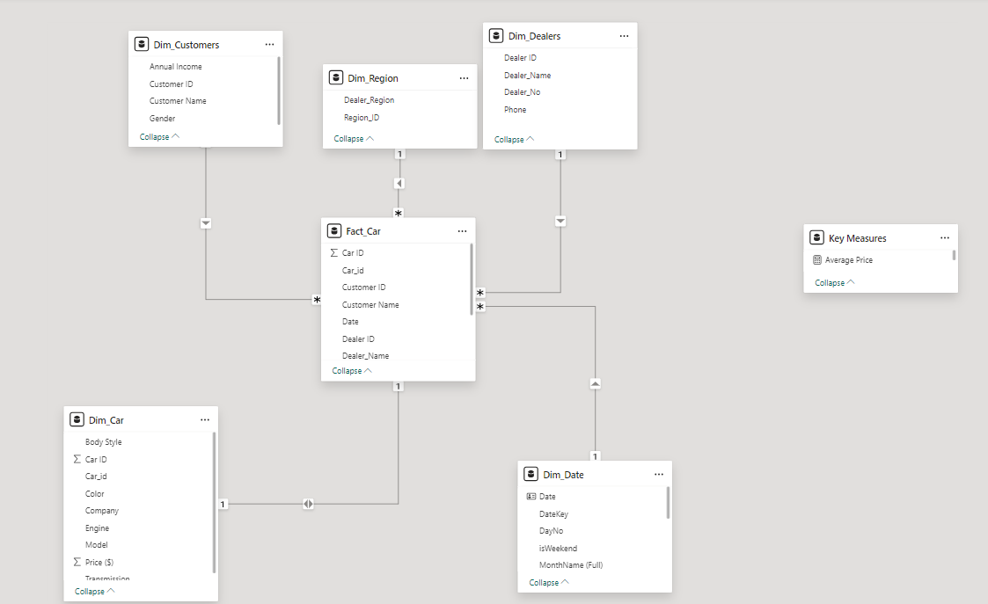

The data from the dataset was organised into 5 separate tables to facilitate analysis:

* **Customers**: Contains the Annual Income, Customer ID, Customer Names and Gender.
* **Region**: Contains the Dealer Region, Region ID.
* **Dealers**: Contains the Dealer ID, Dealer Name, Dealer No and Phone.
* **Car**: Contains Body Style, Car ID, Colour, Company, Engine, Model, Price and Transmission.
* **Fact_Car**: Contains Car ID, Customer ID, Customer Name, Date, Dealer ID, Dealer Name, Dealer No, Dealer Region, Price and Region ID.

**Dashboard Overview**

The dashboard provides a comprehensive view of car sales performance. It highlights Year-to-Date (YTD) and Month-to-Date (MTD) total sales, average price, and cars sold metrics, including year-over-year comparisons. Visuals include weekly sales trends, sales distribution by car body style and colour, a geographical map of units sold by region, and a table showing company-wise sales trends by brand, average price, and total units sold.

**Overview and Sales Trend Dashboard**

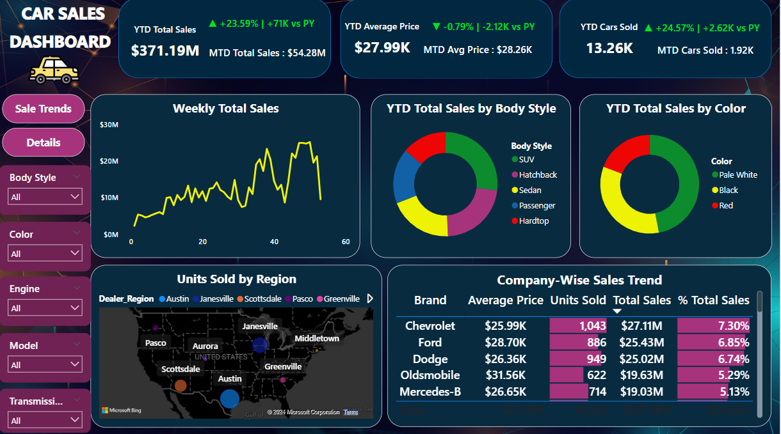

* YTD Total Sales and MTD Total Sales: This KPI card shows the Year-to-Date (YTD) total sales amount of $371.19M, with a growth of 23.59% (+71K units compared to the previous year). It also displays Month-to-Date (MTD) total sales of $54.28M.
* YTD Average Price: This KPI card presents the average price of cars sold Year-to-Date (YTD) as $27.99K, showing a 0.79% decrease compared to the previous year. The Month-to-Date (MTD) average price is listed as $28.26K.
* YTD Cars Sold: This KPI card indicates that 13.26K cars were sold YTD, which is a 24.57% increase over the previous year (+2.62K units). It also highlights Month-to-Date (MTD) cars sold at 1.92K.
* The first line chart visualizes weekly sales trends, showing fluctuations in sales with a peak reaching nearly $26M, providing insight into weekly performance and demand trends.
* The first pie chart shows the distribution of total sales by car body style, with SUVs dominating sales (at nearly $100M), followed by hatchbacks, sedans, and other less popular categories such as passengers ($63.4M) and hardtops ($51.4M).
* The second pie chart displays the sales breakdown by car colour, with pale white being the top contributor to sales (47.02%) while red accounts for only 19.24%.
* The map visualizes sales by dealer region, where Austin shows the largest volume of units sold (2296 units), represented by the largest bubble, while Pasco stood at only 1749 units.
* The table shows a breakdown of sales by brand, indicating average price, total units sold, total sales, and the percentage share of sales for each company. Chevrolet leads with 1,043 units sold and $27.11M in sales, followed by Ford and Dodge.

**Car Sales Details**

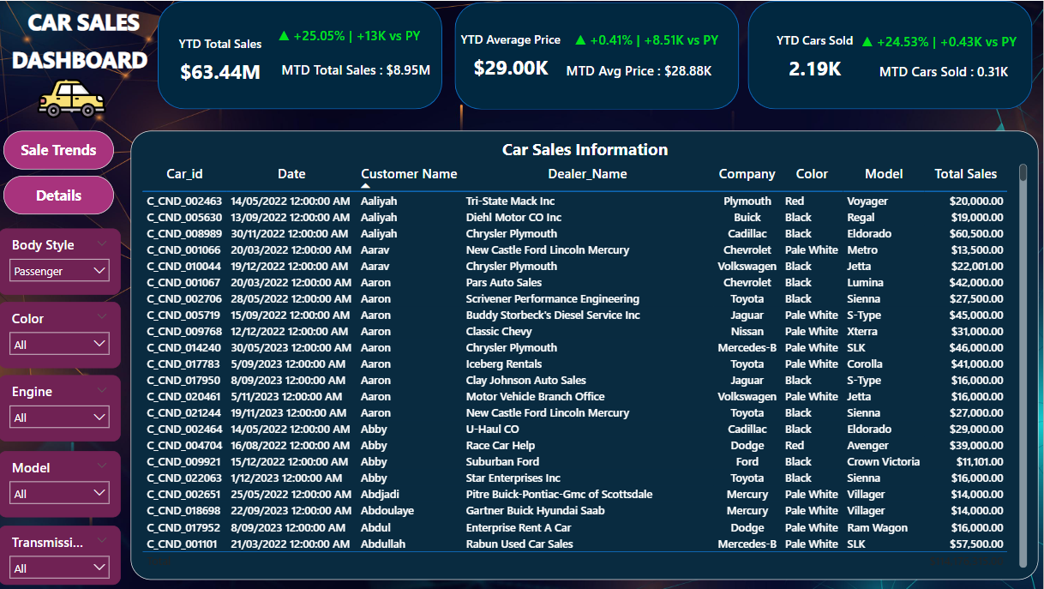

* The table provides detailed information on individual car sales, including fields such as car ID, sale date, customer name, dealer name, company, car colour, model, and total sales amount.
* This grid offers a comprehensive view of each car sold, with varying total sales amounts for different car models and colours.

**Suggestions for the car dealership company**

* Capitalize on Peak Sales Regions: Austin has the highest number of units sold, indicating strong market potential. The company should consider increasing marketing efforts and expanding inventory in this region to leverage this trend further.
* Focus on High-Demand Body Styles: SUVs and Sedans show the highest YTD total sales by body style. The company could benefit from focusing more on these categories by offering special promotions or expanding the variety of models available.
* Monitor Price Sensitivity: While the YTD average price has increased slightly, there is a decline in year-over-year growth for the YTD average price. This suggests some price sensitivity in the market. Consider implementing flexible pricing strategies such as limited-time discounts to maintain competitiveness without sacrificing margins.
* Enhance Sales in Low-Performing Regions: Regions like Greenville and Scottsdale appear to have lower sales performance. Investigating the reasons for this—such as customer preferences, inventory gaps, or lack of marketing—could help the company identify opportunities to boost sales in these areas.
* Promote Popular Colours: Colours like "Pale White" and "Black" are top choices among customers. The company can consider promoting vehicles in these colours more aggressively and potentially offering incentives for less popular colours to balance inventory.
* Strengthen Dealer Relationships: Chevrolet and Ford are leading in units sold, indicating solid dealer performance for these brands. The company should nurture relationships with these top dealers and explore ways to enhance sales through joint marketing efforts, exclusive deals, or loyalty programs.
* Expand Data Analysis: With the rich data available, consider deeper analysis into customer demographics, preferences, and behaviours. Segmenting the customer base could provide insights for personalized marketing campaigns and sales strategies tailored to specific audiences.